WEEK NUMBER: | 1
STUDENT NAME: | Anas Al Azad
STUDENT ID: | 105694136
Week 1 – Introduction to LLM access (local Ollama + cloud Gemini)

WEEK # | 1
Dates covered: | 2–9 August 2026
Lab tasks | What I did | TIME SPENT | Learning & Problems
Getting started  Step 1 + setup | - Read the sheet: what an LLM, an API and a Jupyter notebook are, and running a model locally vs in the cloud.  - Made a separate Python environment for this lab (ollama_venv) and installed ollama, google-genai, pandas and gradio. | 0.5 h | Learning:  - An LLM basically keeps guessing the next word – that's how it 'answers'.  - An API is just a way for my code to send a request (the prompt) and get a response back.  Problems:  - None really for this one.
Local model – Ollama  Steps 2–4 | - Installed Ollama and downloaded the small llama3.2:1b model.  - Called it from my notebook with ollama.chat(...) and asked 'What is an intelligent system?' – it answered with a long list of types, characteristics, uses and examples. | 1 h | Learning:  - Ollama runs a little server on my own laptop (localhost). The ollama library just sends my prompt to it and gets the answer back as JSON – nothing leaves my computer.  - The model file is loaded into memory the first time, so the first call is the slowest.  Problems:  - The small model's answer was a bit generic and not always right – it listed 'self-awareness' as a common characteristic of intelligent systems.
Cloud model – Gemini  Step 5 | - Made a free API key in Google AI Studio and installed google-genai.  - Asked gemini-3.5-flash the same question – a well organised answer (perceive → reason → learn → act, key characteristics, real examples, the technologies behind it). | 0.5 h | Learning:  - Cloud = nothing to download and a much bigger model, but every request goes over the internet and needs the key.  Problems:  - I first typed the API key straight into the notebook. That's not safe (anyone who sees the notebook or my GitHub can use it), so I took it out of the copy I hand in – it should come from an environment variable / .env file instead.
Same prompt on both models  Steps 6–7, student-mat.csv | - Loaded student-mat.csv (student performance data) with pandas and kept the first 20 rows like the sheet does.  - Asked both models how many Male and Female students are in the sex column, with a time.time() wrapper inside each function to log the latency.  - Ollama: 1.32 s – said 8 F and 9 M (only 17 of 20) and then swapped them in its last sentence. Gemini: 3.18 s – 11 F and 9 M = 20, which is right (Fig 1.1). | 1 h | Learning:  - Local was faster here (no internet in between), but fast and wrong isn't much use.  - LLMs don't really count – they read the list as tokens. For counting, pandas (value_counts()) is the right tool.  Problems:  - The local model got the count wrong and contradicted itself in the same answer.
Think step by step vs direct  Step 8 | - Asked the apple question (3 boxes of 12, 5 rotten) once with 'Think step by step, then give your final answer' and once without it, on both models.  - All four answers were 31 (right). Ollama: 1.07 s step by step vs 0.91 s direct. Gemini: 2.09 s vs 1.67 s. | 0.5 h | Learning:  - For an easy question it made no difference to the answer – both models explained their working even without being asked. The direct prompt was just a bit faster.  - My 'direct' prompt only left out 'think step by step'. Asking for 'the number only' would probably show a bigger difference.  Problems:  - None really for this one.
Chat demo with Gradio  Step 9 | - Made a chat page with Gradio's ChatInterface ('Week 1: Local LLM Chat (Ollama)') that sends my message to the local model. | 0.5 h | Learning:  - Gradio turns a normal Python function into a web page in a few lines.  Problems:  - My function only sends the newest message (it ignores history), so the chat doesn't remember what I said before – I'd have to pass the history to ollama.chat for that.  - Importing gradio printed a 'TqdmWarning: IProgress not found' – harmless.  - The sheet says GradioUI, but that's from smolagents (next week), so I used Gradio's own ChatInterface.
Deliverable + checkpoint questions  Comparison table | - Made the comparison table (latency, cost, output quality) from my own numbers and answered the two checkpoint questions – both are below the screenshots. | 0.5 h | Learning:  - Local wins on cost, privacy and (here) speed; cloud wins on quality.  Problems:  - None really for this one.
TOTAL TIME THIS WEEK |  | 4.5 h

Screenshots:
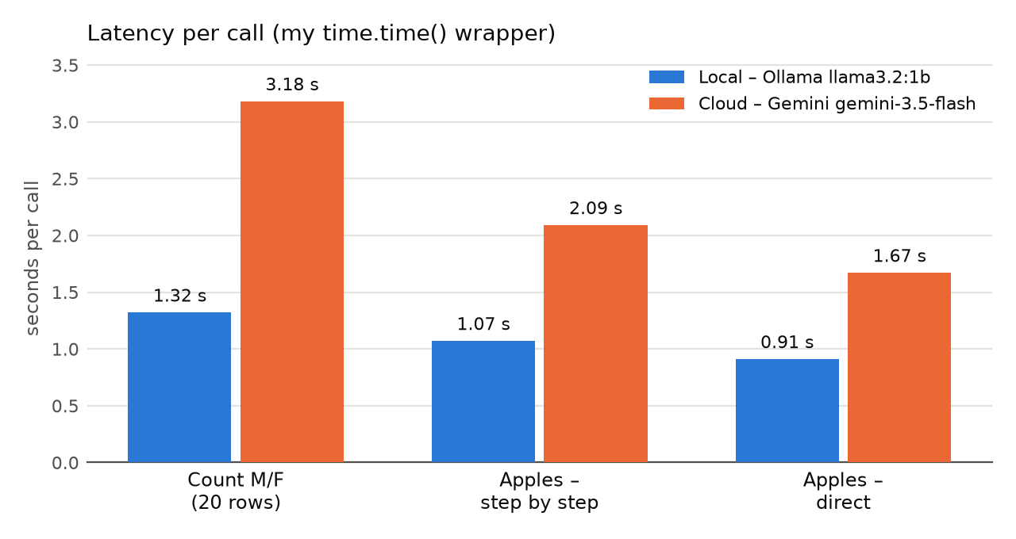
Figure 1.1 – latency per call for each task, local vs cloud (from my time.time() wrapper)
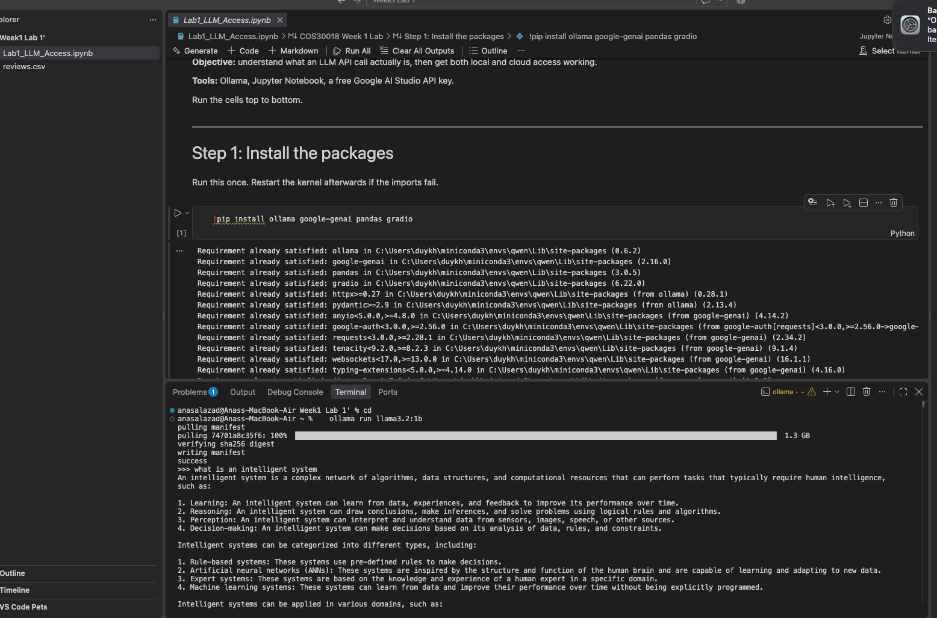
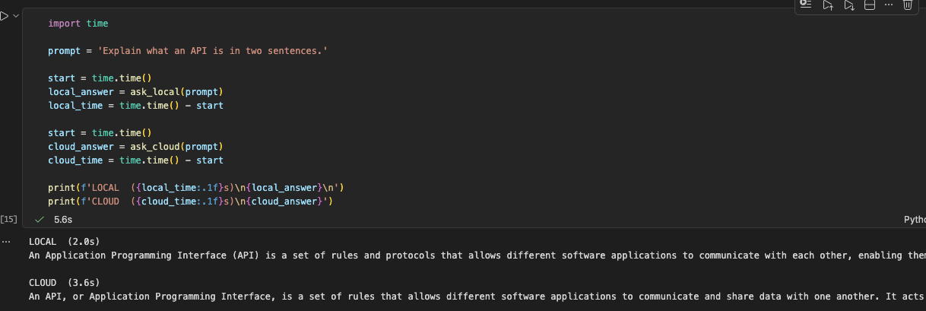
Deliverable – comparison table (latency, cost, output quality)
From my notebook run – latencies are what my time.time() wrapper printed.
 | Local – Ollama llama3.2:1b | Cloud – Gemini gemini-3.5-flash
Setup | Install the Ollama app, download the model (~1.3 GB), pip install ollama. No account or key. | Google account + API key from AI Studio, pip install google-genai. The key has to be kept secret.
Latency – count M/F in 20 rows | 1.32 s | 3.18 s
Latency – apples, step by step | 1.07 s | 2.09 s
Latency – apples, direct | 0.91 s | 1.67 s
Cost | Free – runs on my own laptop (uses my CPU and memory). | Free on the free tier (daily limits); past that you pay per token.
Quality – counting | Wrong – 8 F + 9 M (only 17 of 20), then swapped them around in its last sentence. | Right – 11 F + 9 M = 20.
Quality – apples (31) | Right with both prompts, short plain working. | Right with both prompts, clearer step-by-step layout.
Quality – 'What is an intelligent system?' | Long list, a bit generic – it even called 'self-awareness' a common feature. | Well organised (perceive → reason → learn → act, examples, technologies) and accurate.
Privacy / offline | Nothing leaves my laptop, works offline. | My prompt goes to Google; needs internet.
Checkpoint questions
1. What's the practical difference in setup complexity between local and cloud?
Local: install the Ollama app, download the model once (llama3.2:1b is about 1.3 GB), pip install ollama – then a few lines of code and it works. No account, no key, no limits and it even works offline, but it uses my laptop's memory and processor, so I can only run small models. Cloud: nothing to download, but I needed a Google account, an API key from AI Studio and pip install google-genai. The key has to stay secret (not typed into the notebook), and the free tier has limits.
2. Where did the two models disagree, and why might that happen?
On the counting task. Ollama said 8 female and 9 male (only 17 – there are 20 rows) and then swapped them in its last sentence. Gemini said 11 female and 9 male = 20, which is right. The local model only has about 1 billion parameters, and LLMs don't really count – they read the list as tokens and guess the numbers, so a small model gets it wrong easily. Gemini is much bigger and thinks before it answers. On the apple question they agreed – both got 31 with and without 'think step by step'.

